SPIRITUS CHRISTI
MARRIAGE PREPARATION
†WELCOME

Congratulations on your engagement! We believe that good marriage preparation can make a profound difference in the building of a lifelong loving marriage. At Spiritus Christi we have developed a preparation which takes up to six months for all engaged couples to complete.
At Spiritus Christi Church, we believe that helping couples prepare for this wonderful life-long commitment is a true ministry, and we extend it to any couple who is taking this beautiful step toward a life-long commitment.



Step 1: Complete the Marriage Preparation Registration Form

Your first step is to complete the marriage preparation form and submit a copy to the marriage preparation coordinator. The coordinator will review your registration form, secure your desired wedding date on the church calendar, contact your priest of choice to confirm availability, and assign a mentor couple to work with you through the six topics of the program.

Step 2: Entering the Mentor Couple Program

Each engaged couple will be matched with a married couple from the church. This couple will either arrange to meet at a room at DUPC or invite you into their home for six sessions. Each of our mentor couples have been invited to be on our team because they have something beautiful and spiritual to share with couples who are preparing for marriage. They are all volunteers and freely give of their time as an investment in your marriage. The sessions will focus on the topics of Your Love Story Family, Communication, Expectations, Intimacy, Spirituality and Lifelong Commitment. Our team includes a diversity of couples so that we can find someone who will be a good match for the two of you.

Step 3: Attending Church

We believe the support will have a long, lasting, positive eﬀect on your married life together. We ask all participants of our Marriage Preparation Program, members and non-members, to attend mass regularly while you participate in the Spiritus marriage preparation process. This brings you closer to the community and helps our priests get to know you.

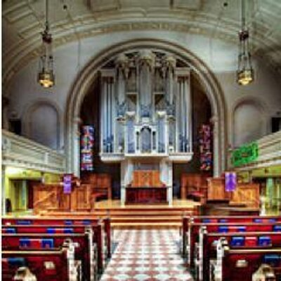

Step 4: Meeting with the Priest
If you are having Rev. Myra or Rev. Fred officiates your marriage, it is important they get to know you. Should you have another celebrant in mind, please let us know. Once you set a date for your wedding, the coordinator will advise Rev. Myra or Rev. Fred of your request and the date of your wedding to check on her availability. As you prepare for marriage, plan to meet twice with Rev. Myra or Rev. Fred. Your mentor couple will work on the ceremony with you and provide the coordinator with the final paperwork.

Reverend Myra Brown

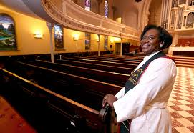

Reverend Fred Dicks


We wish you abundant blessings as you begin to prepare for your lives together in marriage.

Some Questions You May Have

Can we attend this program without being married at Spiritus Christi?
Yes! Our Marriage Preparation process is open to any couple that wishes to prepare deeply and spiritually for this life-long commitment. We do ask that you make every effort to attend Mass at either DUPC or Hochstein while in the program to form a connection with the Spiritus Christi Church community.

Can anyone get married at Spiritus Christi?
At Spiritus, we like to engage couples who are looking for a church community where they can grow and have support for their marriage. We believe the support will have a long, lasting, positive eﬀect on your married life together. If you are not a member, again, we do ask you to attend mass regularly while you participate in the Spiritus marriage preparation process.

Does it cost money to get married at Spiritus?
At Spiritus, we believe our church is here to serve you, so we do not charge for the church or the preparation process. We do ask you to help support the people who will be there to help you celebrate your wedding day.
- Our Spiritus’ musicians charge for their services; fees vary by musician. If you use them, we will provide you with a schedule of their fees.
- Our priests do not charge, but a stipend for their time and travel is always appreciated. $250.00 or whatever you feel comfortable donating is recommended.
- Our sacristans volunteer their time to set up the altar on your wedding day. A note of thanks or small remembrance will bring a smile you won’t forget.

Does my wedding need to be at the church, or can it be somewhere else?
No, it does not need to be in the church. We have celebrated weddings in many beautiful places around Rochester. You can have your ceremony at your reception venue or anywhere you choose. Rev. Myra or another oﬃciant will come to your location to marry you.

Does Spiritus Christi Offer a Wedding Planner?
No. The marriage preparation coordinator and mentor couple will perform rehearsals that are at the church and help you contact the priest. They will also ensure you complete the marriage preparation process. All other arrangements are not part of the process at Spiritus. Also, they cannot perform rehearsals that are oﬀ site.

Why do we have to attend the sessions if we have been together for a while?
We oﬀer these classes as an opportunity for any couple to engage in dynamic communication. The
classes cover a wide and diverse range of topics that come up in relationships of four months or forty years. We know this is a busy time for you, but we are confident that you will be very glad you participated. We always welcome your thoughts.

